Name: Maryam Azhar

Sap ID: 43755

Course: Computer Networks

LAB 7

Task 1:

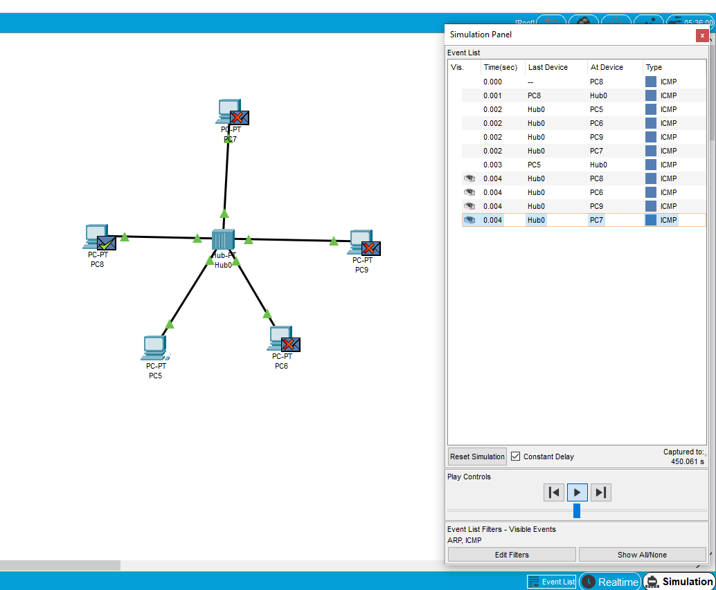

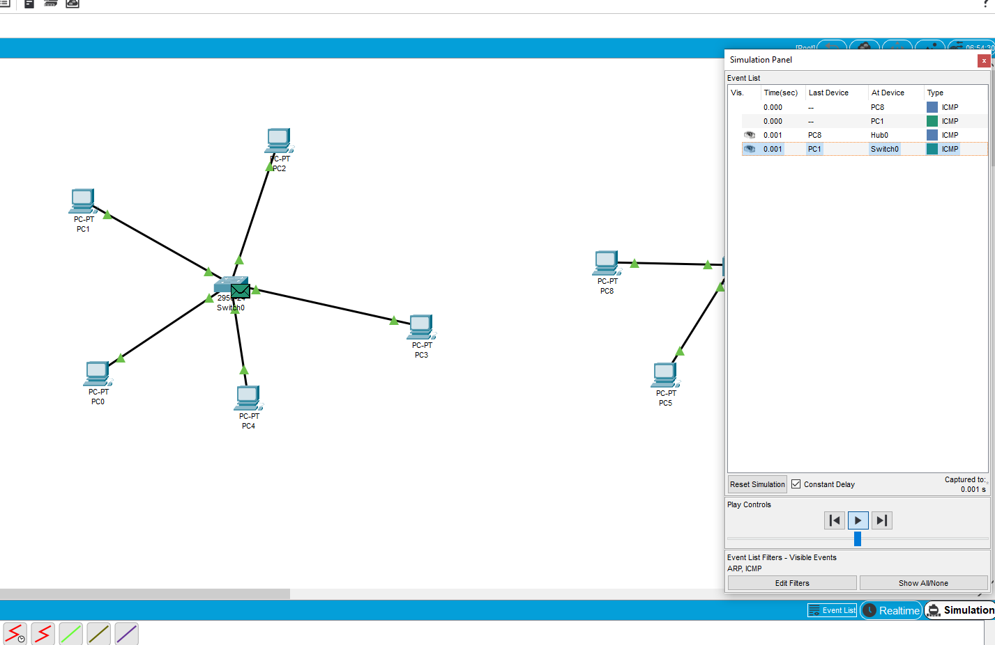

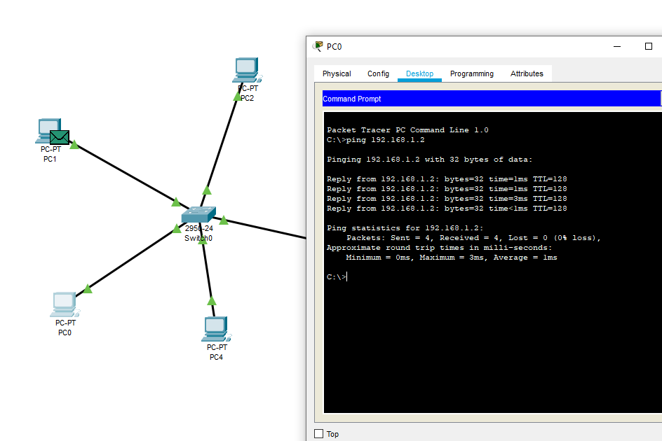

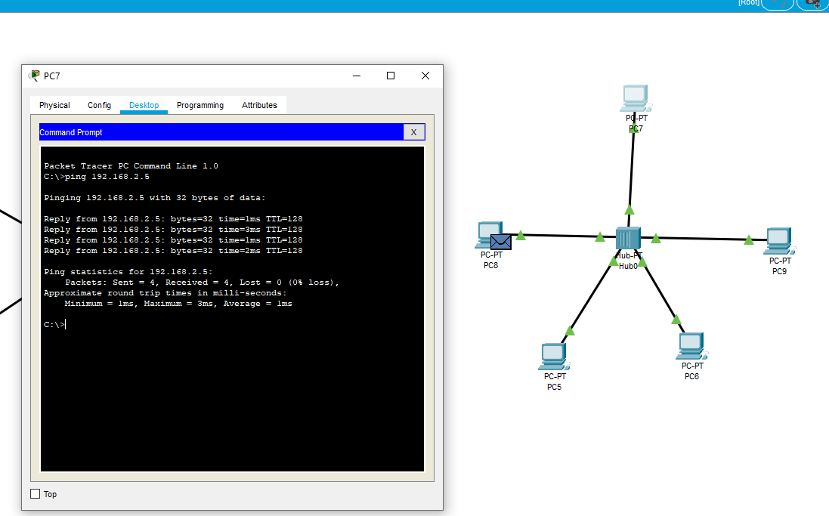

In the first ping, the hub broadcasts to all devices, while the switch learns the destination MAC and forwards directly. On the second attempt, the hub still broadcasts, but the switch efficiently sends the packet directly, using the previously learned MAC address.

Task 2:

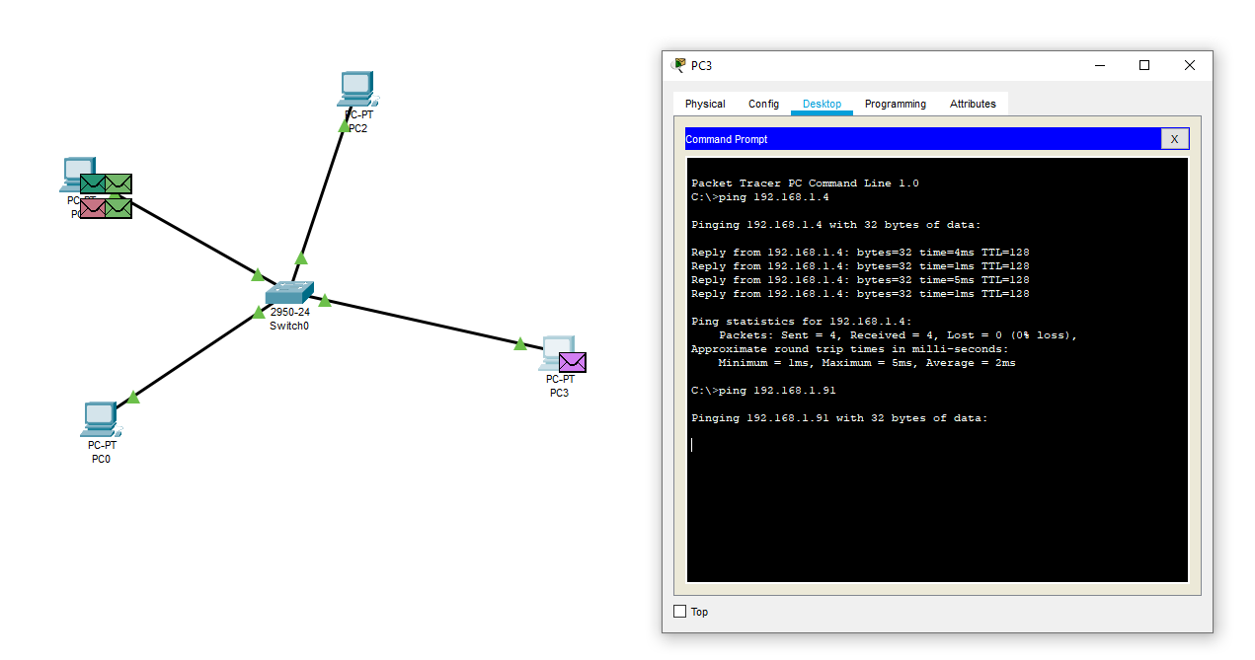

Task 3:

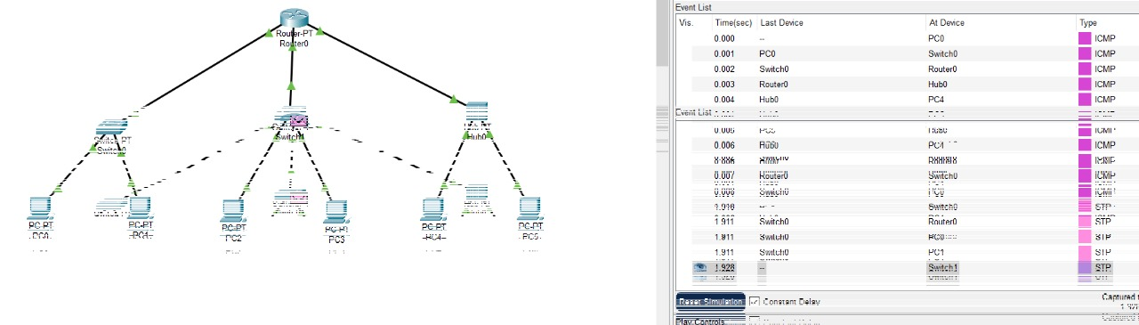

Task 4:

